1. Software Developer

[Software developers](https://www.thebalancecareers.com/software-developer-job-description-salary-and-skills-2061833) create software programs that allow users to perform specific tasks on various devices, such as computers or mobile devices. They are responsible for the entire development, testing, and maintenance of software.

Software developers must have the technical creativity required to solve problems uniquely. They need to be fluent in the computer languages that are used to write the code for programs.

[Communication skills](https://www.thebalancecareers.com/communication-skills-list-2063779) are vital for securing the necessary information and insight from end users about how the software is functioning.

According to the Bureau of Labor Statistics (BLS), software developers earned a median income of $107,510 in May 2019, and employment was expected to grow by 22% from 2019 to 2029—much faster than average for all occupations

## Database Administrator

[Database administrators](https://www.thebalancecareers.com/database-administrator-job-description-salary-and-skills-2061775) analyze and evaluate the data needs of users. They develop and improve the data resources used to store and retrieve critical information.

They need the problem-solving skills of the computer science major to correct any malfunctions in databases and to modify systems in line with the evolving needs of users.

According to the BLS, database administrators earned a median income of $93,750 in May 2019, and employment was expected to grow by 10% from 2019 to 2029, which is faster than average.

## Computer Hardware Engineer

[Computer hardware engineers](https://www.thebalancecareers.com/computer-hardware-engineer-525999) are responsible for designing, developing, and testing computer components, such as circuit boards, routers, and memory devices.

Computer hardware engineers need a combination of creativity and technical expertise. They must be avid learners who stay on top of emerging trends in the field to create hardware that can accommodate the latest programs and applications.

Computer hardware engineers must have the perseverance to perform comprehensive tests of systems, again and again, to ensure the hardware is functioning as it should.

According to the BLS, computer hardware engineers earned a median income of $117,220 in May 2019, and employment was expected to grow by 2% from 2019 to 2029—slower than average.

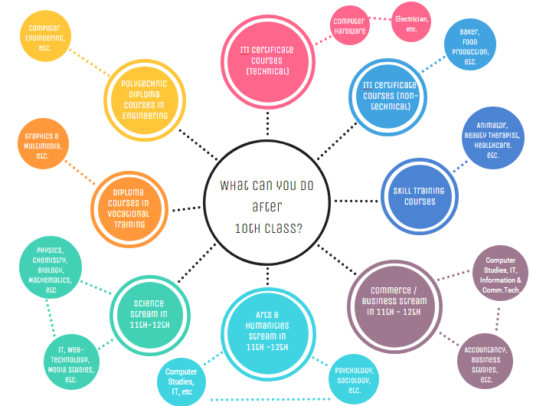

**LIST OF AFTER 10TH COURSES :**

1. [After 10th Courses](https://leverageedu.com/blog/list-of-courses-after-10th-standard/#after-10th-courses)
2. [10th Pass Courses](https://leverageedu.com/blog/list-of-courses-after-10th-standard/#10th-pass-courses)
3. [Popular Diploma Courses After 10th](https://leverageedu.com/blog/list-of-courses-after-10th-standard/#popular-diploma-courses-after-10th)
4. [How to Choose from the Long List of Courses after 10th Standard?](https://leverageedu.com/blog/list-of-courses-after-10th-standard/#how-to-choose-from-the-long-list-of-courses-after-10th-standard)
5. [Polytechnic Courses](https://leverageedu.com/blog/list-of-courses-after-10th-standard/#polytechnic-courses)
6. [Medical & Paramedical Courses](https://leverageedu.com/blog/list-of-courses-after-10th-standard/#medical-paramedical-courses)
7. [IT and Computer Technology](https://leverageedu.com/blog/list-of-courses-after-10th-standard/#it-and-computer-technology)
8. [Engineering](https://leverageedu.com/blog/list-of-courses-after-10th-standard/#engineering)
9. [ITI Courses](https://leverageedu.com/blog/list-of-courses-after-10th-standard/#iti-courses)
10. [Travel and Tourism](https://leverageedu.com/blog/list-of-courses-after-10th-standard/#travel-and-tourism)
11. [Vocational Courses](https://leverageedu.com/blog/list-of-courses-after-10th-standard/#vocational-courses)
12. [Certificate & Diploma Courses After 10th](https://leverageedu.com/blog/list-of-courses-after-10th-standard/#certificate-diploma-courses-after-10th)
13. [FAQs](https://leverageedu.com/blog/list-of-courses-after-10th-standard/#faqs)

**LIST OF AFTER 12TH COURSES:**

* Computer Science. ...
* Medicine. ...
* Pure Sciences. ...
* Pharmaceutical Science. ...
* Cosmetic Science. ...
* Architecture. ...
* Dental Surgery. ...
* Nursing. Nursing is a noble profession which is high in demand across the globe.